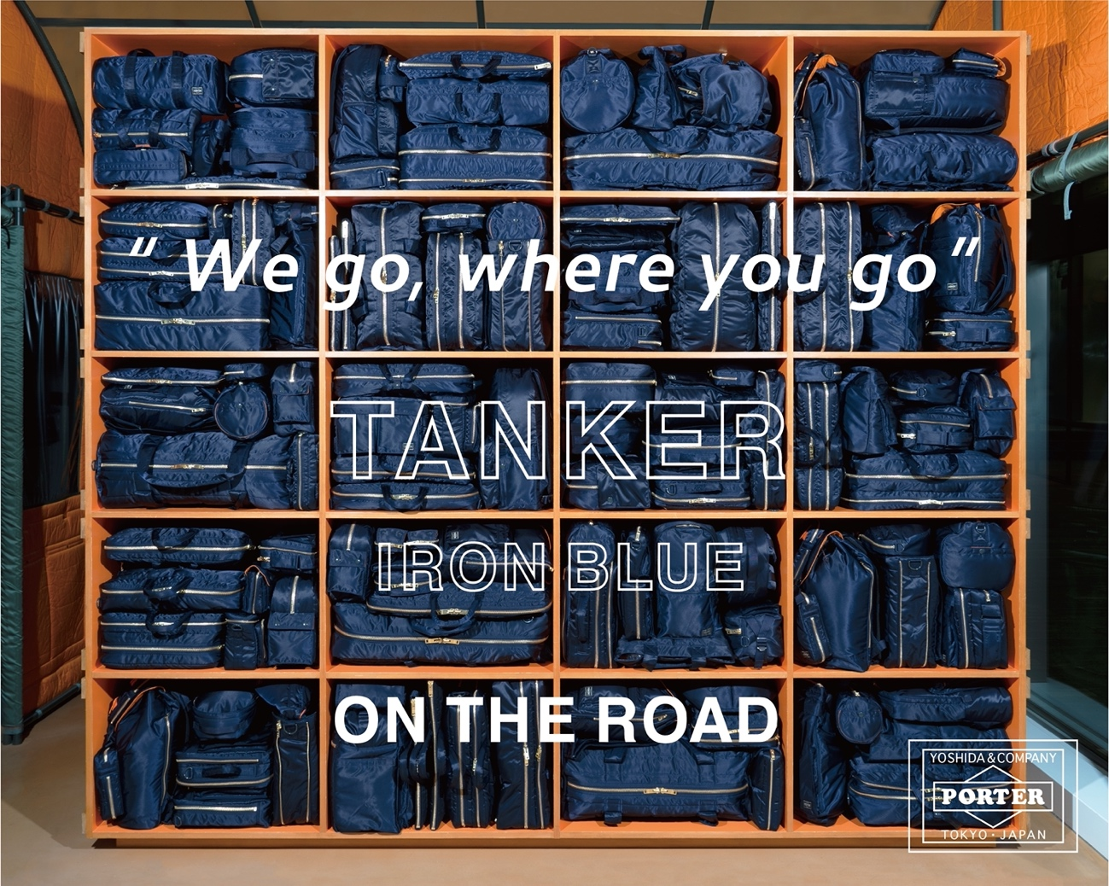

PORTER / TANKER IRON BLUE

A new color "IRON BLUE" will be join for our synonymous with PORTER "TANKER" series.

POP-UP tour called "'We go, where you go' TANKER IRON BLUE ON THE ROAD" will be held in major cities in Japan and abroad to celebrate the launch of TANKER "IRON BLUE".
This tour will also release a limited-edition "Officer Kit" that includes an "Amulet" that can be worn around the neck like an accessory to carry keys and an "ATM Purse" that can be hold multiple cards.

It will start at DOVER STREET MARKET GINZA, a concept store directed by Rei Kawakubo of COMME des GARÇONS under the theme of "Beautiful Chaos".

Date: April 16th (Fri) 2021
Store：DOVER STREET MARKET GINZA

POP-UP TOUR Details
Store：DOVER STREET MARKET GINZA
Period：April 16th (Fri) - May 13th (Thu) 2021
Address: Ginza Komatsu Building West Wing, 6-9-5 Ginza, Chuo-ku, Tokyo
Phone : 03-6228-5080
Openig Hour : 11:00-20:00

DOVER STREET MARKET GINZA here
https://ginza.doverstreetmarket.com/new-items

It will only available at the following stores and our Official Online Store from April 23rd (Fri).
*Please note that the "Officer Kit" will not be available at these stores.

Release date: April 23rd (Fri) 2021
Stores: PORTER flagship store (OMOTESANDO / OSAKA)
PORTER EXCHANGE (SHIBUYA / OSAKA)
Official Online Store
*Available at our Official Online Store from 12:00 PM.

